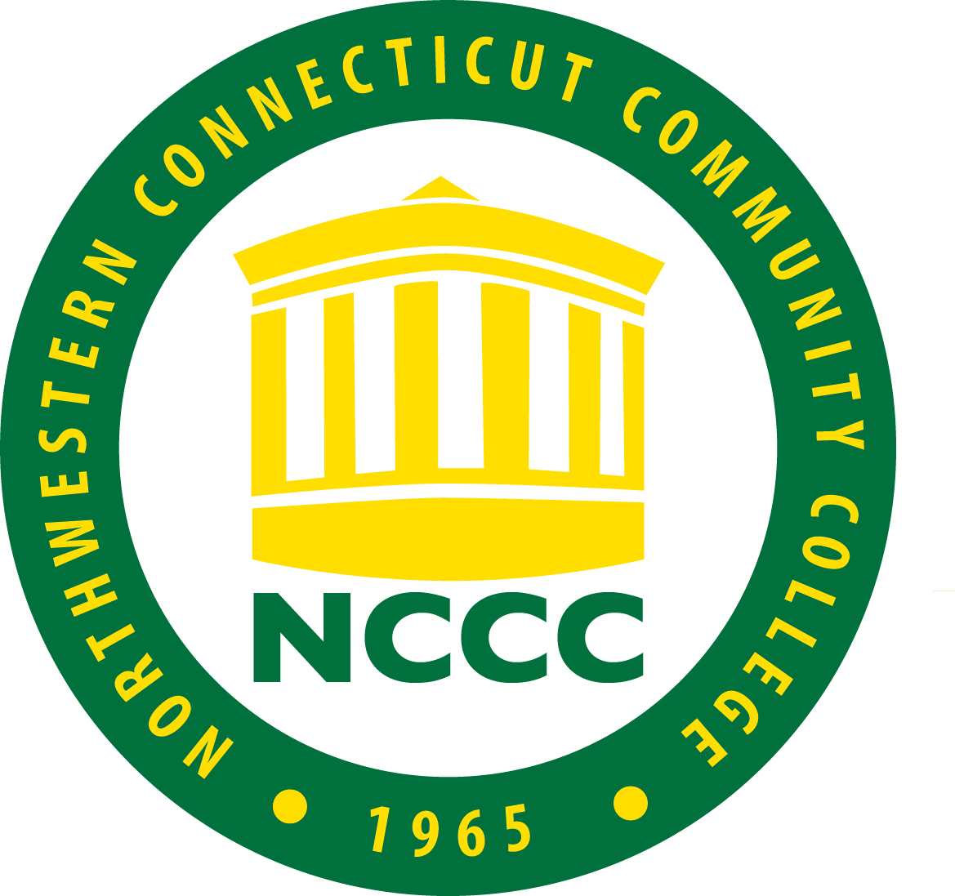
Northwestern Connecticut Community College
Spring Re-Opening Report (Updated 12/11/2020)

REOPENING PLANS FOR UNDERGRADUATE RESIDENTIAL COLLEGES AND UNIVERSITIES

Name of Institution: Northwestern Connecticut Community College
COVID-19 Coordinator: Brian Plessinger, Associate Dean of Campus Operations
Campus CEO: Michael A. Rooke, Ph.D., President
Intended date of arrival of the first students: January 9th 2021
Intended date of classes starting: January 22nd 2021
Intended duration of the Spring semester: January 22nd 2021 – May 17th 2021

Date submitted: December 11, 2020

PART 1 - PLAN FOR REPOPULATING THE CAMPUS (the reentry of students)

Dining Halls: NCCC does not have dining halls as such and will not be providing any food service in the fall 2020 semester.
Classrooms: Declaration that 6-feet of physical spacing has been achieved

The Spring 2021 semester will use the lessons learned and procedures implemented prior to and during the Fall 2020 semester that are detailed in the following bullet points to guide our physical spacing to achieve at least six feet of distance in classrooms that will be used during the semester. Please note that the Fall 2020 academic semester was deliberated for several weeks with faculty, department chairs, and the Dean of Academic and Student Affairs who took into account the recommendations from the CSCU Academics & Enrollment Management sub-committee for classroom options to provide the safest options for students and instructors.

- The College primarily has classrooms that are small in size that would only reasonably hold 3-4 students if 6-foot distancing requirements were implemented. As a result, this limitation makes traditional classes financially impossible to offer in most cases. Additionally, most of the college’s 11 buildings have narrow corridors which makes the safe flow of people difficult to achieve while practicing good distancing requirements. Given these limitations and the fact that the College continues to have faculty with advanced technology skills for online pedagogy, Spring 2021 classes will closely mirror Fall 2020 course offerings with primarily a mix of online synchronous (LRON) and asynchronous classes (ONLN) that match the preferences of our students.

- Approximately 94% of all Spring 2021 classes are either LRON (35%) and ONLN (59%). Most classes with an on-campus component will continue to provide a mix of on-ground and either LRON or ONLN for each class and minimize on-ground activities when possible.

- Distancing: On-ground classes will have limited enrollment equal to the maximum number of students calculated by placing students in the room with a 6-foot clear radius around the students’ positions.
- Since classroom dimensions and immovable structures within each room differ, class sizes will be prescribed on a per-physical-classroom basis. Rooms without adequate ventilation will continue to be deemed not suitable for classroom activities.

- Students will all be required to wear a face mask/facial covering per the Governor’s executive order to limit the spread of the COVID-19 virus.

- The classroom occupancy chart for our Greenwoods Hall multipurpose room:
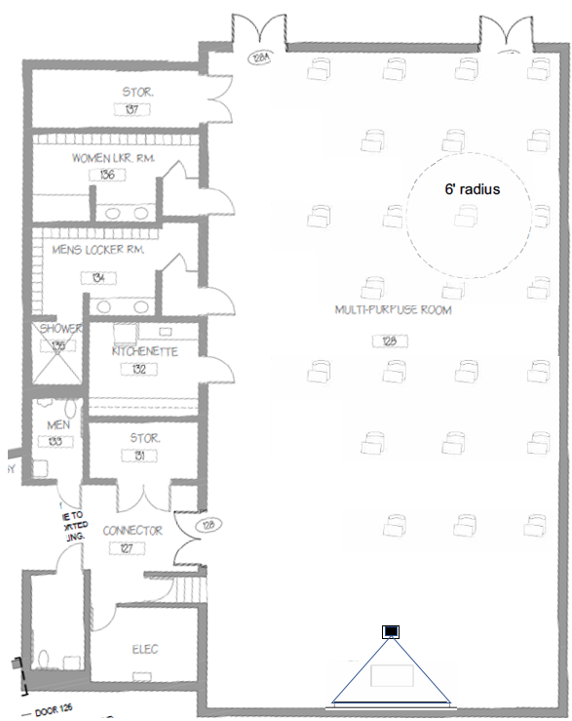

Where six foot spacing is not possible for clinical training or workforce development programs, please describe your plans.

- Classes where physical distancing cannot be achieved: Where a 6-foot radius of physical distancing cannot be achieved in a classroom, additional safety measures will be taken.
- Classes of this type will be planned so as to have the majority of the class performed in locations where a 6-foot radius can be achieved (lecture or a hybrid online model).
- Regardless of whether or not distancing can be achieved, all students and faculty will be required to wear facial coverings (masks) that cover both mouth and nose at all times.
- Where a six (6) foot distance cannot be achieved, additional protective equipment such as face shields or acrylic barriers will be required and available.
- At all building entrances, signage will be posted indicating that anyone who is feeling sick should not enter and to contact the COVID-19 coordinator.
- In building hallways, signage will be placed on the floor indicating the flow of traffic.
- Signage will also be added to public areas, bathrooms and high-congestion areas indicating the following: 6-foot distancing, hand-washing, hand sanitizing, and mask use requirements.
- Hand sanitizer and wipes will be included in all high-traffic areas.

Example Classroom Layouts

Classrooms that require on-campus teaching will have social distancing requirements met by removing excess furniture and wherever possible, floor markings similar to that shown below.

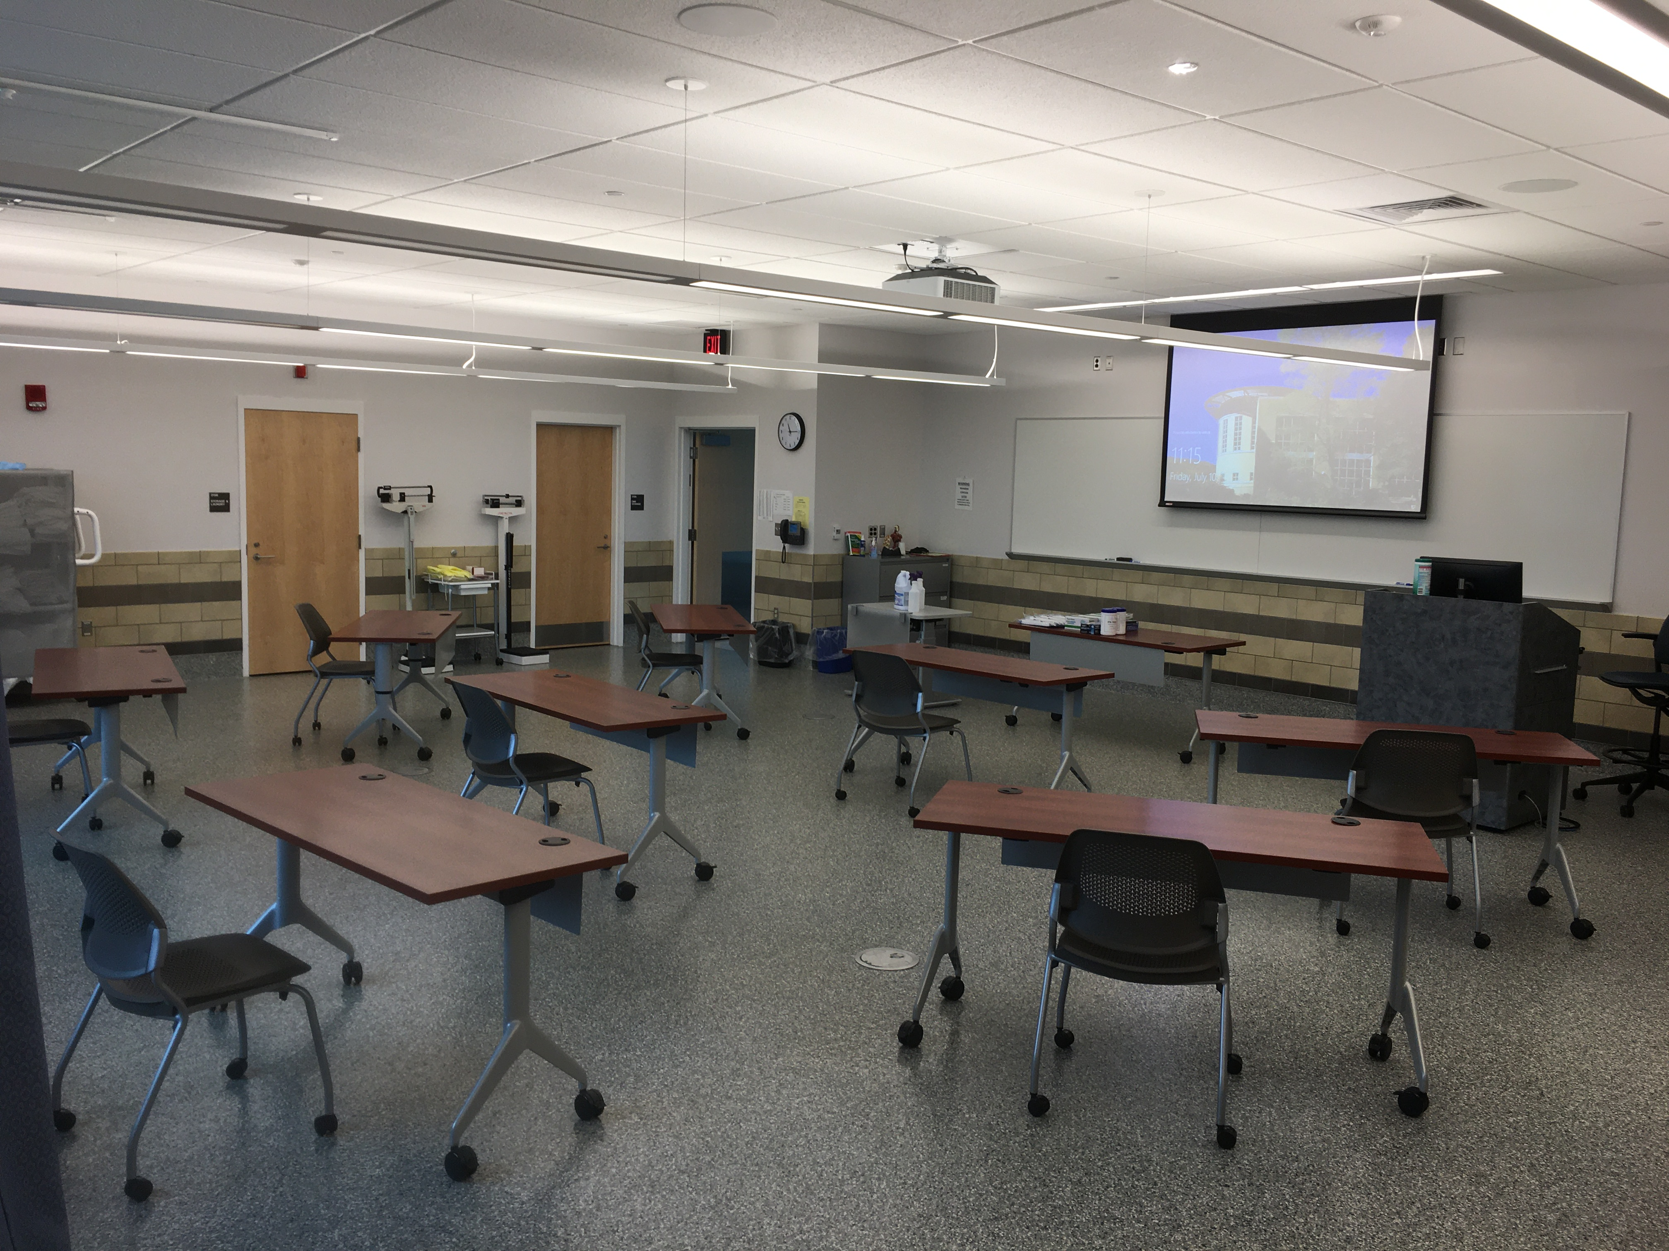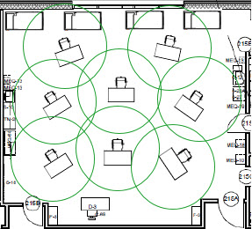

Dining Halls: No Dining Services are provided at the College.
Spaces “where other groups congregate”:
- Any large gathering spaces are to be closed during the Spring semester.
- Small group gathering spaces will ensure a minimum of 6-feet, and all students and employees will be required to self-police their distancing.
- Signage will be posted regarding hand washing, distancing, mask use requirements and symptoms of COVID-19.
- Hand sanitizer and disposable disinfecting wipes will be placed in all high-traffic areas.

Orientation/Arrival: All students will be invited to participate in virtual orientation sessions in January.

Residence Halls: The College does not have any residential facilities.

Personal protective equipment: Masks: Declaration that all faculty, staff and students have been informed to wear masks.

- All faculty and staff have been notified of their requirement and responsibility to wear masks at all times while on campus.
- The College will ask everyone entering the campus to bring their own mask, or will provide masks to anyone not bringing their own.
- Students will also similarly be notified to wear masks at all times, and will be provided masks if they arrive and do not wear one.
- Any student who refuses to wear a mask will be required to leave and will face student conduct consequences for not following campus requirements if they fail to wear appropriate protective equipment.
- Any employee who refuses to wear a mask will be referred to Human Resources and will be required to leave. That employee will be contacted by the Human Resources department for disciplinary action.

Other PPE requirements: All special populations of workers on campus, including our custodial, allied health faculty and students will wear protective equipment specific to their work.

Disinfection: We have provided:
- Hand sanitizer is available at entrances to all buildings, classrooms and high traffic areas,
- Disposable wipes are available in all bathrooms, classrooms and other shared facilities (e.g., copy machines, coffee stations) for wiping down surfaces,
- All bathrooms will have a visible log of cleaning time/date of last cleaning and the regular cleaning schedule
- A non-bleach cleaning solution is used for disinfection in all bathrooms and quaternary ammonium or alcohol-based wipes will be available for users to self-clean
- Students, faculty and staff are reminded to wash hands frequently, and
- Public, corridor and office spaces and their bathrooms are cleaned in accordance with the State’s general guidelines for businesses.
- Signage will be placed at building entrances, floors, in high-traffic areas, classrooms, office doors, etc.

Travel: All students, faculty and staff have been advised to avoid unnecessary travel domestically and internationally and should follow the most current travel advisory restrictions and requirements that are updated weekly and posted at https://portal.ct.gov/Coronavirus/Travel. This requirement may change as conditions warrant.

Staffing: All faculty, students and staff have been explicitly instructed not to come to work or leave their rooms if they are experiencing COVID-like symptoms.

Any faculty or staff who are likely to experience serious health consequences as a result of COVID-19 may be given the option to continue teleworking though the ADA or FMLA process.

Access: Signage will be placed on doors indicating the following:
- No visitors will be permitted on campus.
- Students will only be permitted into buildings and rooms where they have classes.
- Faculty and staff areas that must be on-ground, will be open by appointment only.
- Any faculty, staff or students on campus will be asked to wear a college-issued ID.

General: Per CT guidelines (https://portal.ct.gov/-/media/DECD/Covid_Business_Recovery/general-reopen-051920.pdfV) and CDC guidelines on reopening: (https://www.cdc.gov/coronavirus/2019-ncov/community/reopen-guidance.html)
- Signage has been placed at all doors, high-traffic areas, on floors and walls. Signage to include information on distancing, mask use, procedures, symptoms, prevention, high risk categories, hand washing, etc. using signage provided by CT and from the CDC (https://www.cdc.gov/coronavirus/2019-ncov/communication/print-resources.html)

- Examples:

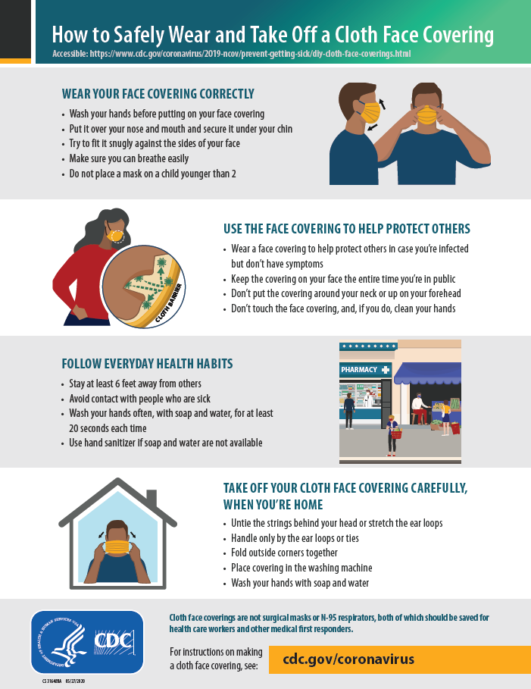 | 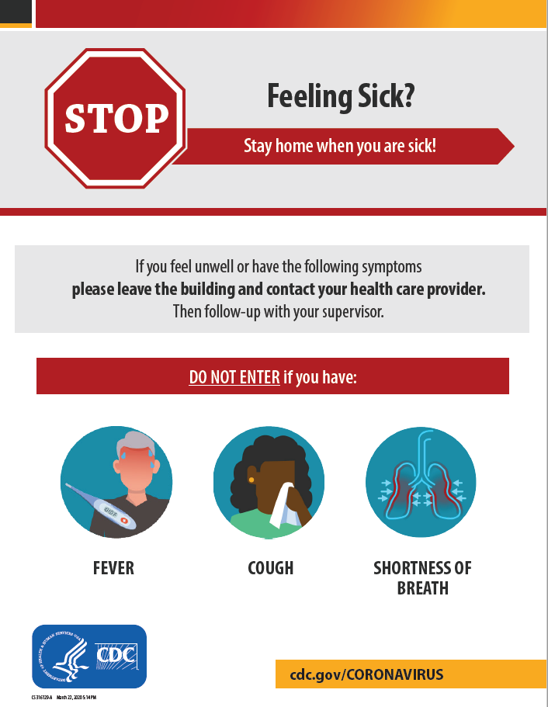
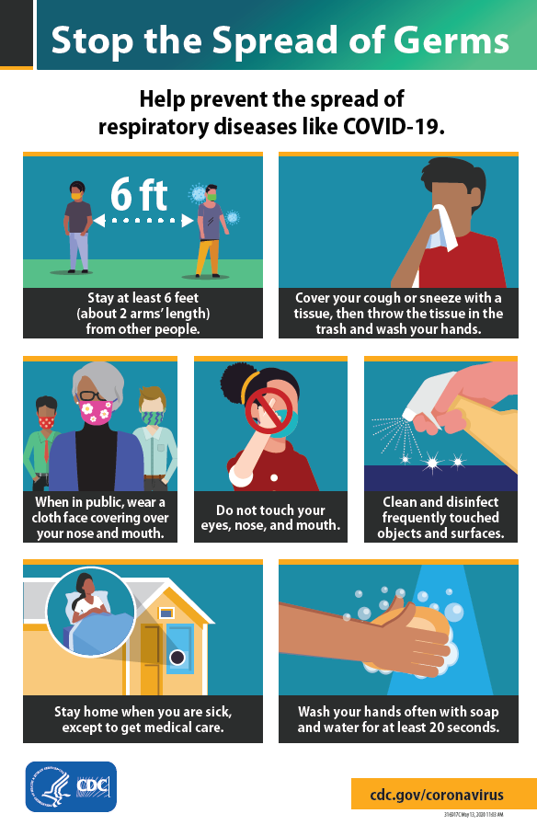 | 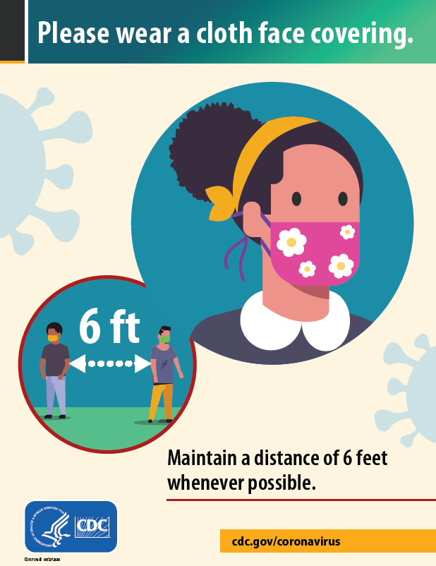

Training:
    - Custodial staff received training on disinfection of the building and facilities as needed: https://www.cdc.gov/coronavirus/2019-ncov/community/disinfecting-building-facility.html
    - Custodial staff received additional training on the use of disinfection equipment and the safe and proper handling of disinfection materials. https://www.epa.gov/pesticide-registration/six-steps-safe-effective-disinfectant-use
    - Employees received training on the symptoms of COVID-19 so they are able to spot and report such symptoms: https://www.cdc.gov/coronavirus/2019-ncov/symptoms-testing/symptoms.html
Entry:
    - Building entry will be restricted only to buildings in-use – all other areas will remain locked
    - Building entry to in-use areas will be self-policed - Northwestern CT Community College does not have security staff to monitor or regulate the entrances – anyone entering a building will do so at their own risk and in compliance with posted signage regarding their health upon entry.
    - Sick students and employees are not allowed in the buildings – this is to be self-policed.
    - Signage will be posted at each entrance defining symptoms and stating that anyone experiencing any symptoms not enter the building. Signage will include COVID-19 coordinator contact information to self-report illness.
    - Signage will be posted indicating that all people entering any building will be required to wear a facial covering (mask) either home-made or manufactured – must cover nose and mouth – at all times while in the building and on state grounds.
    - Upon entry, students and employees will report their attendance and confirm their health status to their defined contact using a QR code system on every entrance/exit. The code will link to a Microsoft web form which asks the person to verify compliance with appropriate safety questions.
PPE Use:
    - All people entering buildings will be required to wear a facial covering.
    - Any student who does not have their own mask/face covering will have a disposable mask provided to them by their instructor. Masks will be available in all classrooms and office locations.
    - The Facilities department will be responsible for storing and distributing all PPE. Any employee needing a supply of masks or other PPE can request an additional supply from Facilities.
    - All employees have been issued with 5 reuseable cloth masks. All employees will be responsible for cleaning and maintaining the cleanliness of their issued reusable masks.
    - Custodial staff performing disinfection will be given appropriate protective equipment as listed in the CDC guidelines on disinfection below:
Disinfection:
    - Following CDC Guidelines: https://www.cdc.gov/coronavirus/2019-ncov/community/disinfecting-building-facility.html
    - Using EPA-registered disinfectants effective in killing the SARS-CoV-2 virus: https://www.epa.gov/pesticide-registration/list-n-disinfectants-use-against-sars-cov-2
    - Performing disinfection safely: https://www.epa.gov/pesticide-registration/six-steps-safe-effective-disinfectant-use

Sick Employees: Employees who are sick, are to stay home and contact their supervisor indicating that they are feeling sick. Supervisors receiving a report of a sick employee will notify the COVID-19 coordinator to follow-up with that employee. Return to work is to be determined by the administration (COVID-19 testing may be required).

Attendance:
    - Employee: all employees will NOT report to the campus if they exhibit any symptoms. Supervisors will record and report all positive test results to the COVID-19 coordinator and to the College President, for reporting to the local and state public health departments.
All employees will be required to immediately leave the campus and not return until cleared to do so by a health official.
    - Students: all students will similarly report any symptoms and immediately remain away from campus and online in such a case or take a sick leave of absence from the class if unable to continue.
Occupancy:
    - All bathrooms will be considered single-occupancy. Signs are currently in place on all bathroom doors directing individuals to knock on the door before entering to determine whether the bathroom is currently occupied.
    - Occupancy signage will be posted for all rooms used (classrooms, bathrooms, offices, etc.).
    - Room occupancy will be based on room square footage of available floor-space using a six-foot radius circle as the distance between individuals.
Ventilation:
    - Multiple occupancy building use will be limited to those buildings that have the proper ventilation
    - Rooms with restricted airflow (internal rooms, rooms with recirculating air-movers, etc.) will not be used for classes or multiple occupancy use.
    - As much as practical with building systems and daily environmental conditions, building HVAC fresh air intake will be increased during normal operating hours and after scheduled hours will be run maximizing the fresh air intake to complete two complete air exchanges.
    - HVAC filters installed have been verified to be or are scheduled to be changed to MERV 8 or better.
    - Classrooms with negative-pressure HVAC systems will be preferred for use where possible.
    - Classrooms with rapid air exchange HVAC systems will be used where available

Other Preventive Measures:

    - Alcohol-based hand sanitizer stations are in all high traffic areas, on hallway walls and in classrooms.
    - Disposable disinfectant wipes are provided in all classrooms and high traffic areas.
    - Bathrooms will be disinfected daily using approved quaternary ammonium based disinfectant disinfectant.

    - Cleaning Shared Workstations
In places such as the library, the Center for Student Development and the Tutoring Center, and open computer labs, where surfaces such as computers and printers are handled by multiple users, it will be the responsibility of each user to clean keyboards, computer mice, work surfaces, and any other equipment (printers, copiers) before and after each use. Disinfectant will be provided, and signage will be posted that provide instructions.

PART 2 – PLAN FOR MONITORING THE HEALTH OF STUDENTS, FACULTY AND STAFF

Community colleges and other non-residential institutions with only commuting students are not required to test students. However, commuter colleges should formalize relationships with local departments of public health to support referrals for testing and contact tracing.

Appointment of a COVID-19 Coordinator: Declaration of who the Coordinator is and that he or she will (i) be the liaison with the coordinators at the other colleges and universities who will convene periodically during the fall (and beyond if needed) and (ii) oversee reporting for the common Dashboard that will be developed for the higher education sector.

Brian Plessinger – Associate Dean of Campus Operations will be the COVID-19 Coordinator and collect and report all information regarding a daily census of each individual case of COVID-19. Brian will act as the liaison with other coordinators within the CSCU system and the Departments of Public Health.

Protocol for collecting information about COVID-19 cases: Declaration that the institution has developed a protocol indicating that faculty, students and staff have been asked to inform immediately the campus health service (or a designated administrator) that they are experiencing possible COVID-19 symptoms, as well as a protocol for testing symptomatic students. (For students, faculty, or staff using an external health care provider, the institution should request that they inform a designated administrator if they test positive.)

Definitions for reference:
- COVID-19/Coronavirus – https://www.who.int/health-topics/coronavirus
- Coronavirus symptoms - https://www.cdc.gov/coronavirus/2019-ncov/symptoms-testing/symptoms.html
Protocol for collecting information:
- All employees and students have been informed via multiple channels (signage, email, orientation, website) that they MUST report testing positive, so that we can assist local public health officials with contact tracing.
- Signage will be placed at all building entrances indicating symptoms and will include language stating entry is not permitted for individuals that are symptomatic.
- Signage will indicate the procedure to contact the COVID-19 Coordinator via email or phone if symptoms occur.
- Anyone reporting as symptomatic will be documented by the COVID-19 Coordinator.
- Symptomatic individuals will be isolated and sent home to self-quarantine.
- All symptomatic people will be directed to seek treatment from their healthcare provider if needed and given information on available local testing sites.
- Those documented will be contacted to determine the outcome of the testing and recorded.
- Once an individual tests positive and informs the COVID-19 Coordinator of the positive test, the COVID-19 Coordinator will share the individual’s positive test to the appropriate local public health agency officials and assist local public health agencies with class rosters, staff appointment schedules, and daily campus access logs if helpful in contact tracing.
- Any information that is shared with public health officials is to help perform follow-up on all those who show symptoms and those who have come in contact with those individuals who test positive for COVID-19.
- The COVID Coordinator will also inform the campus CEO and gather specific information on when the individual was last on campus, their role on campus, their schedule for 2-3 days prior to their last day on campus, etc. In the event the infected individual is a student, the Dean of Students should be made aware of the positive test or the HR manager in the case of an employee.
- Information will be kept confidential and only shared with COVID-19 regional coordinators and/or public health officials to help protect communities and prevent the spread of infection.

Contact tracing: Declaration of how the institution intends to conduct contact tracing.

The CSCU Community Colleges are not required to implement contact tracing. Contact tracing will be led by the local department of public health and should not be initiated by the colleges.
Positive test results will be reported to the state directly from the testing providers and contact tracing will commence. Employees who have tested positive will be contacted by the health department to check on their condition and to identify potential individuals who may be impacted by close contact with the infected employee. Those contacts will hear from the health department as well to check on their condition and recommend steps to address potential exposure. Employees should indicate that they work at one of the community colleges and provide their recent activities. Schools can share class rosters, staff appointment schedules, and daily campus access logs to the local health department if helpful in the contact tracing.
Should an employee be notified of a positive test result, they are encouraged to contact the COVID Coordinator at their campus. The COVID Coordinator will share that information with the local department of public health. The department will work with the school should steps be necessary to address the spread of virus on campus and conduct the contact tracing as outlined above.

Liaison with regional hospitals and health care facilities: Declaration that the institution has been in contact with the key health care facilities in its area and has a liaison at each to assist if a surge occurs on campus and/or in the region.
Northwestern CT Community College has established relationships with the public health officials listed below who will be contacted should contact tracing become necessary.

- Leslie Polito,Torrington Area Health District, has been designated as our local Health contact person should we have an outbreak.
Public Health Nurse
Leslie Polito, BSN.,RN.
lpolito@tahd.org
860-489-0436, Ext. 313

Anastasiya (Stacy) Domnich-Kovalevsky, MPH
adomnich-kovalevsky@tahd.org
860-489-0436, Ext. 314
- Northwestern CT Community College has a collaborative relationship with Charlotte Hungerford Hospital in Torrington. CHH contact person is Tim LeBouthillier (860.415.6544 (cell) 860.496.6544 (office) Tim.LeBouthillier@hhchealth.org) or if Tim is not available, Brian Mattiello, Regional Vice President for Strategy & Community Development (860-485-4542)

PART 3 – PLAN FOR CONTAINMENT

Isolation space: Declaration that the institution has designated rooms and feeding arrangements for students who test positive and must be isolated.

- The isolation space on campus will be located in the White Building. This is an area that is to be used as a temporary staging and isolation area for students that cannot immediately leave the campus, and must be isolated from others. The building will otherwise be closed and unused.

Isolation protocol: Declaration that when a case of infection is detected, the institution will isolate the infected students for 14 days, trace contacts, quarantine all roommates and suitemates and consider quarantining others with close contact.

- N/A

Medical care for those isolated: Declaration of how the institution intends to provide medical care for infected students.

- Since Northwestern CT Community College is a non-residential campus and there is no infirmary on campus, symptomatic students will be required to leave campus, self-isolate, and when appropriate, seek medical attention, get tested for COVID-19 and report those results back to the COVID-19 coordinator.
- Those who cannot leave campus immediately (whether due to extreme sickness or lack of transportation), will be isolated in the White Building and transportation will be arranged (whether medical or personal depending on the circumstances.)
- Those who are physically too sick to seek medical attention on their own, will be isolated and emergency services will be contacted to bring the student to the nearest available emergency department (911 call for medical help).
- Quarantine protocols will be explained and resources to receive medical or other support services will be provided.

Quarantine protocol: Declaration that the institution intends to quarantine students who are judged to require it.

- N/A

PART 4 – PLAN FOR SHUTDOWN

Shutdown initiated by the institution if a serious outbreak occurs on campus: Declaration of the protocol for an orderly shutdown if a serious outbreak occurs on campus that the institution or relevant state or local authorities conclude requires shutdown. This may warrant different treatment of local students and those who need to travel to other states or countries.

- All employees and students are encouraged to notify the COVID Coordinator if they have tested positive for COVID-19. Local departments of public health will also be notifying the COVID Coordinator of positive cases that are reported to the state that are linked to the campus.

- The COVID Coordinator should inform the campus CEO and gather specific information on when the individual was last on campus, their role on campus, their schedule for 2-3 days prior to their last day on campus, etc. In the event the infected individual is a student, the Dean of Students should be made aware of the positive test or the HR manager in the case of an employee.

- Once information has been gathered on the circumstances, the CEO should inform the Regional President who will meet with Alice Pritchard, CSCU Chief of Staff and Keith Epstein, VP of Facilities to discuss recommended next steps.

- Each school should identify a local action team (including facilities, communications, human resources, etc.) to implement steps to mitigate the spread of the virus as discussed with the CSCU team. After these discussions, the COVID Coordinator will inform the local public health department of plans to address any outbreaks and seek additional guidance. No campus can be closed without concurrence from CSCU system office and planned communication strategy to internal audiences and the public.

Shutdown of the State: Declaration that the institution will follow the instructions of the Governor if he determines that a state-wide shutdown is again required.

- Should the Governor determine a State-wide shutdown is required, Northwestern CT Community College will immediately shut down campus operations, notify students and employees via the Everbridge alert system and email notification, and migrate services back to the online model that was practiced on the initial shutdown of campus-based operations.

Plan for continuation of instruction if a shutdown occurs: Declaration about whether the institution would intend to continue instruction online if a shutdown occurs.

- Instruction for any on-ground courses in place at the time of a campus shutdown will be moved online wherever possible. Those classes that cannot be run online, will be addressed on a case-by-case basis by administration with the guidance of the CSCU leadership.

- If gating conditions cannot be met in time for the Spring semester to begin, any courses that were planned for on-ground operations will be moved online or cancelled if there is no method for achieving a reasonable outcome from an online modality.

* * * *

