CT Preschool through 20 & Workforce Information Network (P20 WIN)

Data Destruction Certificate

This form is completed in order to document that the unit record data received through P20 WIN has been destroyed. Data destruction is required at the end of an approved audit or evaluation or in the event of a termination of the Memorandum of Agreement for a P20 WIN Data Request. In the case of an approved audit or evaluation, the timeframe by which unit record data must be destroyed is determined and approved by the P20 WIN Data Governing Board.
The Data Destruction Certificate must be completed and provided to the P20 WIN System Administrator within 3 working days of the destruction of data. The Approved Requestor shall retain the original certificate for a period of one year after its submission to the Board.

Section 1 – Basic Information

- Approved Requestor Name: Andy Condon
- P20 WIN Data Request Number: P20W_1511_3_0008
- Approved timeframe for audit/evaluation:
____11-5-2015__________________ to _____4/11/2017 (e-mail from Russ Adair on 4/12 confirms that the data set was sent to DOL on 4/12. DOL had 12 months from the date of receipt before destruction.___
List extensions as appropriate:
Extension to ______________ granted on ________________________
Extension to ______________ granted on ________________________

- Date of data destruction:

December 2016
- Method of data destruction:

Original files and copies in SQL server deleted. MS Access copies: records deleted from tables.
(AKA MOAB)

Section 2 – Affirmation of Destruction

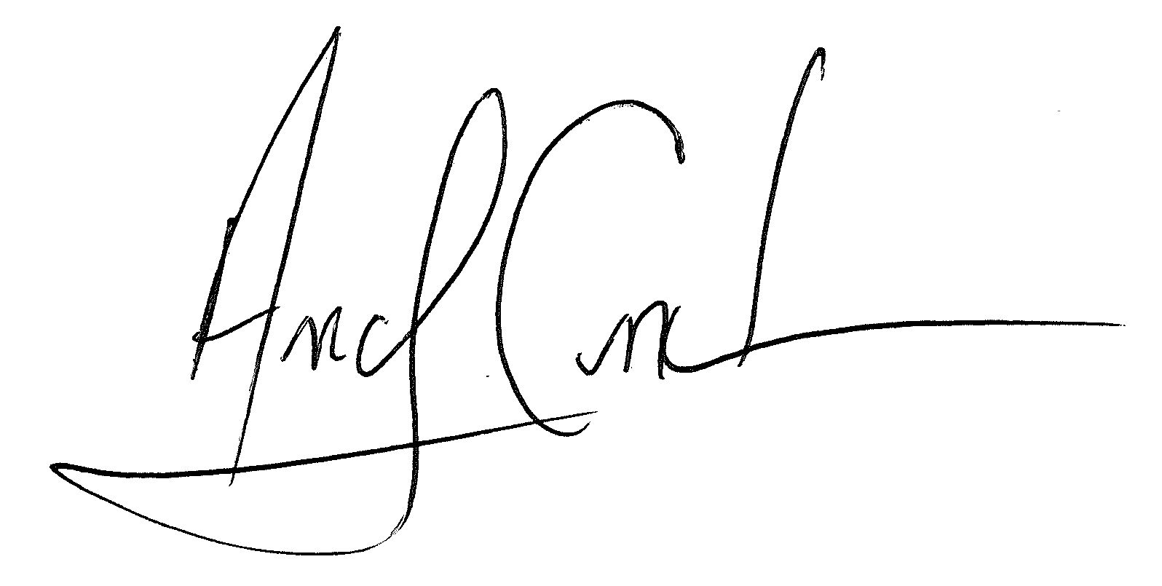
I hereby affirm that the unit record data provided as a part of the Data Request Number listed above has been completely destroyed including all original unit record data and any copies of the unit record data that were made in paper or electronic form.

______________________________________________________ ___4/17/2017__________________________
Signature of Approved Requestor or Agency Representative Date

